Pentecost Sunday Rev. MaryBeth Ingberg
Immanuel UCC; May 23, 2021
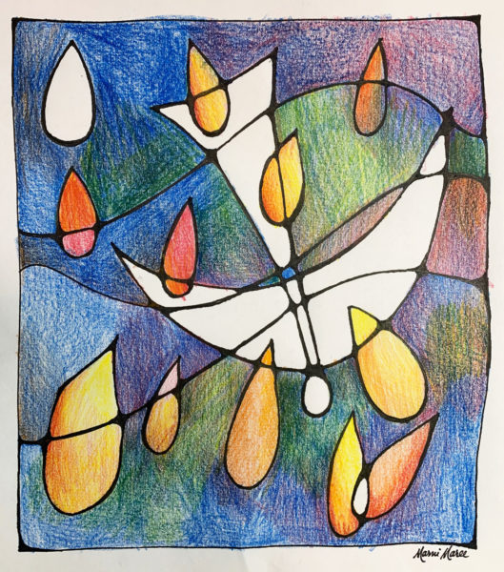

Acts 2:1-21
When the day of Pentecost had come, they were all together in one place. And
suddenly from heaven there came a sound like the rush of a violent wind, and it filled
the entire house where they were sitting. Divided tongues, as of fire, appeared among
them, and a tongue rested on each of them. All of them were filled with the Holy Spirit
and began to speak in other languages, as the Spirit gave them ability.
Now there were devout Jews from every nation under heaven living in Jerusalem.
And at this sound the crowd gathered and was bewildered, because each one heard
them speaking in the native language of each. Amazed and astonished, they asked,
“Are not all these who are speaking Galileans? And how is it that we hear, each of us,
in our own native language? Parthians, Medes, Elamites, and residents of Mesopotamia, Judea and Cappadocia, Pontus and Asia, Phrygia and Pamphylia, Egypt and the parts of Libya belonging to Cyrene, and visitors from Rome, both Jews and proselytes, Cretans and Arabs—in our own languages we hear them speaking about
God’s deeds of power.” All were amazed and perplexed, saying to one another, “What does this mean?”
But others sneered and said, “They are filled with new wine.”
But Peter, standing with the eleven, raised his voice and addressed them, “Men of Judea and all who live
in Jerusalem, let this be known to you, and listen to what I say. Indeed, these are not drunk, as you suppose,
for it is only nine o’clock in the morning. No, this is what was spoken through the prophet Joel:
‘In the last days it will be, God declares, that I will pour out my Spirit upon all flesh, and your sons and
your daughters shall prophesy, and your young men shall see visions, and your old men shall dream dreams.
Even upon my slaves, both men and women, in those days I will pour out my Spirit; and they shall prophesy.
And I will show portents in the heaven above and signs on the earth below, blood, and fire, and smoky mist.
The sun shall be turned to darkness and the moon to blood, before the coming of the Lord’s great and glorious day. Then everyone who calls on the name of the Lord shall be saved.’

Prayer: God of Creation, the wind blows and we hear the sound of it, but we do not know where it comes from. Rush into this place and fill every nook and cranny with dreams and visions of possibility. Turn our hushed whispers into proclamations of your grace, in every language of the world. Lead us into your holy future as we pray in the name of Christ. Amen.

“Prophesies, Visions and Dreams”

I can’t say that I’ve ever experienced being overcome by the Holy Spirit; at least not in the way it appears the disciples were as Luke describes in his Book of the Acts of the Apostles. Maybe overcome wouldn’t be the right word for me ~ better to say emboldened ~ and those other “e” words like empowered and encouraged. Now that, I could say, what about you? Perhaps you remember a time when insight or courage, even calm surprised you. Maybe a sense of joy, thankfulness and wonder washed over you in the midst of an ordinary day. Haven’t there been times in the life of this church, when, for the sake of others, in the midst of helping, serving, comforting, teaching … even gardening! that all we are and all we do is motivated and sustained by the Spirit of God’s love?

Today is Pentecost Sunday. And speaking of words, “Pentecost” comes from the Greek for “fiftieth day,” pente-costē. Today we mark the end of our season of Easter – seven weeks after Easter, adding that day: fifty days. It’s also a Jewish festival, which is why the followers of Jesus were gathered together. The Jewish feast of Pentecost, Shavuot, celebrates the Law given by God to Moses on Mount Sinai – seven weeks after Passover, adding that Sabbath day: fifty days. Enough of this vocabulary and math!

The disciples are together for the festival of the Giving of the Law. It’s been less than two months and they are still recovering from their grief at the crucifixion, the joy at the resurrection, and confusion over Jesus’ brief stay with them until the Ascension when he disappears with the promise to send the Advocate, the Holy Spirit, who will empower them to bear witness to God’s love for all the world.

Like the original disciples, and every generation of disciples since, we are reminded that God still moves among us, calling us to open our hearts to the Spirit of creativity, mercy, adventure and courage. Yes, adventure and courage: the disciples’ experience of the Spirit’s power didn’t always lead to peace and serenity. They struggled and faced persecution, they discovered, as we often do: sometimes the Holy Spirit causes more turbulence than tranquility. In our particular time and place, it’s easy for us to forget that Jesus was criticized for including everyone, ridiculed for taking sides with the vulnerable instead of the powerful. Jesus was rejected because he was not what people were expecting in a Messiah.

God’s love is large enough to include everyone. The boldness of the Apostles’ witness is given by God who, in Jesus, chose to suffer with the weak rather than wage war against them; who, through Christ, returns sin with mercy rather than judgment. We find our unity in the Holy Spirit, not in acts of strength but in our shared humanity, vulnerability, and need. The Spirit of Pentecost invites us to take risks and helps us to see possibilities in the midst of problems, opportunities despite obstructions.

On this Pentecost Day, we bear witness to the presence of God’s Holy Spirit in the love we show each other, the care we extend to neighbor and stranger alike – in the risks we take on behalf of the vulnerable, the challenges we accept on behalf of the stranger. We may not have tongues of fire on our heads and maybe the wind won’t come swirling around us. While some of us may speak more than one language, in Christ, when we speak the language of healing, inclusion and welcome, folks won’t assume we’re drunk by 9:30 in the morning. They will see that we are an inviting, compassionate, generous and Spirit-filled people. We may not be overcome with the Holy Spirit in the same way the disciples were. But, by that same Spirit, we are given those “e” words to enact God’s love for others: emboldened, encouraged and empowered!

Today we are reminded that God is present: in Zoom services, parking lot worship, in-person gatherings with singing prohibited, and in our attempts at a return to “normal” whatever that may be. This Pentecost, as with all the others in centuries past, God is Still Speaking. This Pentecost, God is present in the many ways we choose to welcome the Spirit in our midst: with helium balloons? wearing red? hearing Scripture in many languages? releasing doves? a holy bonfire? blessing a garden? sharing a picnic lunch? and hearing opera? In the many ways we and our sister churches are choosing to celebrate, we all hear the same Good News: God is with us: gracing us with the Holy Spirit so that we can bear witness to God’s love and forgiveness with all the world. Amen.

